

Rocky Mountain
Woodturners

Newsletter
November 2008

www.woodturner.org

A Chapter of the American
Association of Woodturners

Next Meeting is at the Loveland Woodcraft.
Next to The Merchantile, off the Crossroads Exit

>>> Nov 6th, 6:30 pm Thursday <<<

3718 Draft Horse Drive
Loveland, CO 80538

Demonstration this month
by
Pete Holtus
Christmas Ornaments

Upcoming Meeting Schedule!

Nov 6th – Pete Holtus, Turning Christmas Ornaments
Dec 4th – Christmas Party?
Jan 4th – Election of Officers, Demonstrator ??

Meeting Format
.6:00 – 6:30 – Setup and Social Time, come visit, share ideas and ask questions
6:30 – 7:00 – The general business meeting.
7:00 – 8:30 – Demonstrator time.
8:30 – 9:00 – Clean up and out by 9 pm sharp!

What’s Happening in the RMWT?
Yes, the Board is doing something useful (at least we think so). The RMWT Officers Board held a meeting on October 14, 2008, and laid out several activities and changes that should improve your Chapter of the AAW.
- A Newsletter Team was formed to help Kevin. The team members are Kevin Dunn, Pete Herman, Randy Gleckler and John Giem. John was asked to become Editor of the Newsletter.

www.rmwt.org

- Dave Amos is working on a Grant Proposal to the AAW to improve our audio – visual capability. Aaron Reeves is assisting and has identified some improved sound equipment.
- The Board is taking action to improve the websites. Hoyle Cutis has volunteered to be the Web Master. Improvements are being investigated and are expected to be implemented early next year. Details to follow.
- We are working on getting an on-line discussion group set up to ask questions and exchange ideas.
- We are taking a comprehensive inventory of all of the equipment owned by RMWT and the Symposium. If you have any RMWT equipment, make sure that Mike Davis is informed about it.

Small Hollow Forms
Presented by: Allen Jensen
Reported by: John I. Giem
The demonstration for the RMWT on October 9, 2008, was presented by Allen Jensen. The presentation was on making small hollow forms.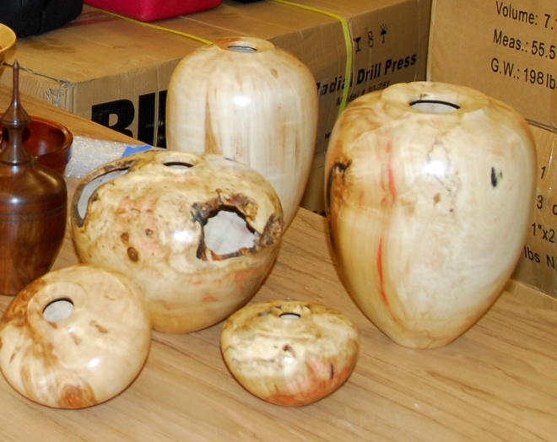
Figure 1. Hollow forms turned by Allen Jensen
Allen used box elder for his demo. He started by mounting it between centers on the lathe. The spur center was inserted into a one inch hole that had been drilled into one end.
A tenon was turned at the tailstock end to be used for mounting the blank into the jaws of a chuck. Factors important to the holding power of the jaws on the tenon include:
- The bottom of the surface of the form at the base of the tenon must be perpendicular to the axis of rotation or slightly concave. This is to provide the nose of the jaws the best support for holding the tenon.
- The length of the tenon must not be too long or the jaws cannot properly seat against the bottom of the vessel resulting in poor griping power.
- Due to the way the jaws are built and the resulting geometry, the best holding power is obtained when the jaws are almost closed when tightened around the tenon.
- Use the largest sized jaws possible. Larger jaws allow usage of larger tenons and are thereby stronger and hold better.
Allen roughed out the shape while between centers but did not try to finalize it to the finished form.
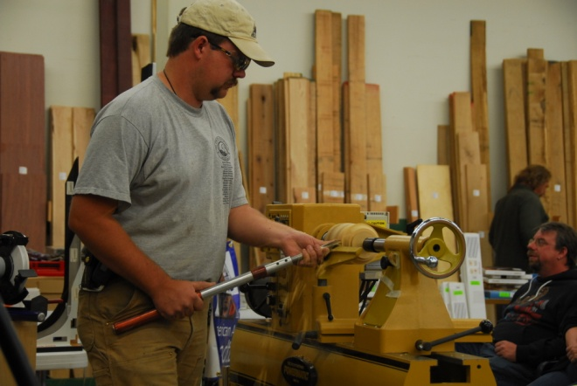
Figure 2. Allen Jensen
After roughing, it was reversed and mounted in a chuck using the tenon. At this time, he finalized the shape of the form except for the base. The base was left large enough to support the weight of the vessel and to minimize vibration. Even though the base still contained a lot of waste wood, Allen shaped the sides right up to the edge of the waste. He left a sharp corner between the side wall and the waste. This corner then ‘points’ toward the intended position of the bottom thus giving visual clues to him while hollowing out the inside.
Once the form is mounted in the chuck, he does not remove it until the piece is finished. If the piece were removed and remounted, there is a high risk of it not being properly centered causing a lot of extra work or even complete loss of the project.
When hollowing, he normally uses compressed air to blow the chips out of the vessel. In this demo, we did not have compressed air available but he lucked out in that the blank had a void in it. This enabled the chips to be ejected out of the hole in the side.
Allen had an idea about the shape he was trying for before he ever started the chainsaw. Using the chainsaw, he rough cut the blank accordingly. Further roughing, if needed, is done on the bandsaw. As the blank is being roughed on the lathe, it starts revealing itself and the shape is refined accordingly.
To begin the hollowing process, Allen uses a small gouge to define the center and make a starting hole. A long drill bit was marked with masking tape indicating the inside depth of the vessel. The drill bit was mounted in a handheld chuck. With the lathe running slowly, the drill was used to make a hole down the center of the vessel to the desired position of the interior’s bottom.
It is necessary to frequently remove the bit and clear out the chips. It can be frustrating if the chips are not removed and they bind up locking the bit into the hole.
The top of the vessel was then refined opening up a hole large enough to work through with the hollowing tools. Leave some waste around the edge to compensate for possible damage caused while turning. Special precautions must be considered if any voids extend into the edge around the openings. You don’t want any of your tools to get trapped in the void while turning.
The majority of the hollowing is done with a straight hollowing tool which uses an arm brace mounted to the handle. The hollowing process uses the previously drilled depth hole to gauge the progress.
The straight hollowing tool cannot reach up into the shoulder area of the vessel adjacent to the opening at the top. To clean out the shoulders, he uses a hollowing tool with the cutter mounted at an angle, an angle cutter, so that it reaches out to one side. Care must be used or the torque generated while in use can surprise the user resulting in a damaged bowl.
Allen has found that long sweeping strokes with the hollowing tool are less likely to break through the sides. The inside is finished up using a tear drop scraper mounted on a ‘bent tool’ so that he can clean up the shoulder areas adjacent to the opening.
After the inside is finished, he further refines the outside base and cleans up the outside surfaces using shear scrapping.
Keeping the sides of the vessel as uniform as possible promotes uniform warping while drying and minimizes the risk of cracks.
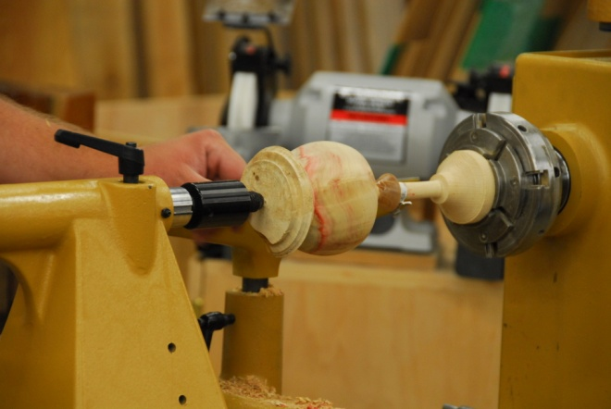
Figure 3. Shaping the base while mounted on special jam chuck.
After the outside has been refined, he again reverses it to complete the bottom. The form is mounted using a special ‘jam chuck’ that has a very long slender ‘nose’ on it that can reach all the way to the bottom of the vessel. Also on this long slender nose or rod is mounted a movable cone. The Vessel is mounted over the rod and the tailstock is used to clamp the bottom of the vessel between the end of the rod and the live center. The cone on the rod is then slid into the mouth of the vessel to support and center it. The bottom can now be refined and finished.
Green wood, especially box elder is difficult to sand and finish so it is allowed to dry before the finishing process.
When using green wood, he turns his vessels to a uniform thickness of about three-sixteenths of an inch. After it is finished, He removes it from the lathe and buries it in a pile of fresh turning chips and allows it to dry for a couple of months.
Allen finishes his bowls with sanding sealer, re-sands and then uses spray lacquer.

The following was requested to be inserted in this issue, as per David. (Editor)

DAVID NITTMANN WOODTURNING www.davidnittmann.com
P.O.B. 19065; Boulder, CO. 80308 Ph/Fax 303.449.7170 david@davidnittmann.com
SHIPPING: 5854 Rawhide Court, Studio A; Boulder, CO 80302
A Note of Apology to Rocky Mountain Woodturners
It was brought to my attention that I was being argumentative during the business meeting October 9th. I would like to clarify my position. Woodturning is a very important part of my life. I wish to point out that people should not confuse my passion with argument. I was attempting to suggest a possible method of resolving the on-going dilemma of club membership and AAW membership. I do not advocate forced AAW membership on any interested woodturner who would like to belong to the RMWT or any other organization associated with woodturning. I was citing an example of incentives used by the Irish Woodturning Guild (the national organization) for 100% participation to one of our AAW board members (Frank Amigo) who had the floor and was discussing AAW business. I felt this was an appropriate time to make a suggestion that could be carried to the AAW board meeting as well as heard by our own membership. I apologize to Frank and the RMWT membership for any misunderstanding and disruption to the meeting.
Sincerely,
David Nittmann

The Library is a Great Asset!
Are you taking advantage of your RMWT Library? We have a large selection of videos, and other reference materials. Dave Amos is in charge of the Library and is planning purchasing more material over the next year. Don’t forget to check for information to use in your next project. Be sure to return the videos in a timely manner so that the next person can check them out. After all it is only common courtesy to your fellow RMWT member.
Attention Members!
Club members cannot sell videos or other items at Woodcraft during meetings. Woodcraft's sales tax license will not allow this. Any questions should be directed to Drew Nichols, our president.

Wood Storage Bank
As we have discussed before, we are collecting wood for our group. There are 3 of us collecting wood. They are Dave Amos, Bruce Pilkington and Kevin Dunn. We are still getting this rolling. But I have a huge box elder tree and a very nice blue spruce trunk that I acquired. Also, I have past blanks and projects available. Whatever doesn’t get spoken for, goes to feed my fireplace this winter. Kevin Dunn
970-420-9691 dnnkk@msn.com

WOODCRAFT
Woodcraft does offer 10% discount to all members on RMWT Club meeting nights.

Your membership card will get you a discount at several local turning supply retail stores. You can get your membership card from John Giem.
~~~~~~~~~~~~~~~~~~~~~~~~~~~~~~

Learn from the best…
Our Club, RMWT, is becoming known around the nation because we have some of the best turners, nationally known demonstrators and best teachers of Basic Turning, Intermediate, and Advanced and Specialty turning right here in our own back yard.

Trent Bosch Woodturning Workshops
Workshops are held in Trent’s studio in Fort Collins, Colorado. There is a maximum of four people in each class which allows for lots of individualized instruction. The cost is $500 for the 3-day intensive workshop and $650 for the 4-day. Meals are also provided at no extra charge. His studio is also equipped with the highest quality equipment available for your use. For detailed information on workshops visit www.trentbosch.com or contact Trent via email or phone.

Trent Bosch
Trent Bosch Studios Inc.
trent@trentbosch.com
970 568 3299

Lee Carter operates the Rocky Mountain School of Woodturning in LaPorte, Colorado. He offers classes in Basics, Intermediate and Advanced. Lee also offers private tutoring. 7 different brands of lathes are available.
Call Lee Carter at 970-221-4382 to sign up or have him answer any questions.
e-mail LLJTC4X4149@ CS.COM
________________________________

Curt Theobald offers three-day workshops in Segmented Woodturning in his studio in Pine Bluffs, Wyoming.
Call Curt Theobald at 307.245.3310
E-mail cwtheobald@wyoming.com
Website is www.curttheobald.com

John Giem, Woodworker
Woodworking instruction customized to the needs of the student. Offering both woodworking on the lathe and combined with regular power tools. Classes are held in John's workshop in Fort Collins, CO, which is equipped with a complete set of woodworking tools. Contact John to discuss rates along with your interests and needs.
jgiem@comcast.net
(970)223-0844, home phone
(970)227-6618, cell phone

Woodcraft has classes for beginners in woodworking, shop safety, intro the machines, bowl turning, pen and pencil turning, hollow forms, Christmas tree ornaments, tool sharpening, etc. Please check out the class being offered at web page

www.woodcraft.com/stores/store.aspx?id=56

Wood Suppliers
Woodcraft
3718 Draft Horse Drive, Loveland
Woodcraft offers 10% to woodturners, on the night of the meeting. Discount applies to wood and equipment, excluding major power tools

10% Guild discount at the following:

The Wood Emporium

618 N Garfield Ave Loveland, Co 80537

Sears Trostel

1500 Riverside Ave Ft. Collins, CO 80524
Rockler’s in Denver – You have to show your membership card.



2008 Officers, Directors and Committees
President: Drew Nichols
970-566-4662
dcnichols2004@msn.com

VP: John Giem
970.223.0844
jgiem@comcast.net

Treasurer: Richard Bailey
303-252-1405

Secretary / Newsletter: Kevin Dunn
970-420-9691 Cell
dnnkk@msn.com

Program Director: Trent Bosch
970.568.3299
trentbosch@yahoo.com

Librarian: David Amos
970.834.1432
dcjeamos@juno.com

Symposium Director
Mike Davis - mikeldavisllc@msn.com
Allen Jensen 970-663-1868
Rajconst@aol.com

Webmaster – Hoyle Curtis
hoyle.curtis@gmail.com

Clubs and Member’s
Websites

Rocky Mountain Wood Turners
www.rmwt.org

AAW – American Assoc of Woodturners
www.woodturner.org

Trent Bosch
www.trentbosch.com

David Nittmann
www.davidnittmann.com

Cindy Drozda
www.cindydrozda.com

John Lynch
www.johnlynchwoodworking.com

Curt Theobald
www.curttheobald.com

Copying of this newsletter is strictly advised. Please do and pass on to another fellow woodworker or woodturner!

Rocky Mountain Woodturners
Educational Opportunity Grant
Applications are due at the Christmas party meeting in December, a decision will be made in Jan 2009.

The purpose of this document is to describe the Rocky Mountain Woodturners Educational Opportunity Grant program. Rocky Mountain Woodturners is a chapter of the American Association of Woodturners (AAW), located in Loveland, Colorado. Please visit the Rocky Mountain Woodturners (RMWT) web site at www.rmwt.org, and the AAW web site at www.woodturner.org. The RMWT meets on the first Thursday after the first Tuesday of each month at 7:00 PM at the Woodcraft Store in Loveland, Colorado.

Applications for an Educational Opportunity Grant (EOG) from the RMWT are available each year. Applicants may apply by completing the attached application form and submitting it to Rocky Mountain Woodturners.The RMWT’s would like to assist you in your woodturning education. If you have a particular goal, workshop, or project in mind and need financial help, we would like you to apply to this program.
In order to expand and share woodturning resources, RMWT has established a fund from which grants are awarded to individuals and organizations. The grants will cover expenses such as tuition, registration, demonstrator's fees, travel, lodging, and meals, with each individual grant not to exceed amount set by the board.
(1) Purpose of the Program
- To allow RMWT members to benefit from their own fundraising efforts and generous support.
- To provide educational opportunities that expand and enrich the entire community.
- To provide ways that woodturning skills may be shared with RMWT members, seminars, schools, and friends.
- To create opportunities for members who would otherwise not be financially able.
- To allow persons outside the RMWT community to experience the benefits of woodturning.
(2) Eligibility
Applicants must be a member or sponsored by a member of the RMWT. Recipients must submit a report on their experiences within three months of their completion.
(3) Grant Committee
RMWT shall establish a Grant Committee comprised of three members including a Chairperson and two others. The Chairperson shall be appointed by the RMWT Board. The Grant Committee Chairperson shall select two additional committee members. The Grant Committee serves at the pleasure of the RMWT Board. The board may change the committee chairperson at any time.
The Grant Committee shall perform the following duties:
1. Review applications for Educational Opportunity Grants
2. Inform the board of all EOG applications
3. Make recommendations to the board, including recommending which grants should be approved, and for what dollar amount. Grant committee members shall vote with the board on grant approvals. Applicants must gain three/fourths support of the board & EOG committee in order to be approved.
4. Awards will be considered based on benefit to the community, concept, and economic need. Emphasis will be placed on the ability, as well as the opportunity, of an applicant to share information gained.
5. The Grant Committee chairperson shall follow-up with recipients of EOGs to insure projects are completed on a timely basis, and that recipients present their results at a meeting of the RMWT, and provide a written report which can be included in the RMWT newsletter and/or be posted on the RMWT web site.
6. The Grant Committee may recommend an EOG be awarded in unusual circumstances (relief, short-notice need, gift, etc.) without the submission of an application.
(4) Submitting an Application
Applicants shall complete the attached form, and submit it to:
EOG Chairperson
Rocky Mountain Woodturners

Rocky Mountain Woodturners
Educational Opportunity Grant
Application Form

Please provide clear and concise answers to the following questions:
Name: __________________________________________________________
Date: _______________________________ Phone: _____________________
Address: ________________________________________________________
City, State, Zip Code: ______________________________________________
E-Mail Address: ___________________________________________________
1. How would you use the educational grant?

2. How would you benefit from the grant?

3. How would the community benefit from your grant?

4. Please give an itemized budget of how you intend to use the grant.

TIPS ON USING THIS FORM:

- Type, print or write legibly, your answers to the questions.
(If you download a copy from the RMWT website, you can download it in MSWord and type your answers right on the form, print and mail it to the RMWT.)

- Please do not submit CD’s or notebooks full of supporting data or photos. The grants are rated by the content of the answers to the questions. They are considered on their own merit.

- Please answer the questions in a clear and concise manner. Include additional sheets, if necessary.

- Please provide the name that will appear on any award check

- Budget: It is OK for your budget to exceed the award amount.

- Applicants may apply for a grant to:
  - Attend a symposium, workshop, or school.
  - Enable a special project.
  - Cover teaching expenses.
  - Any other reasonable cause

